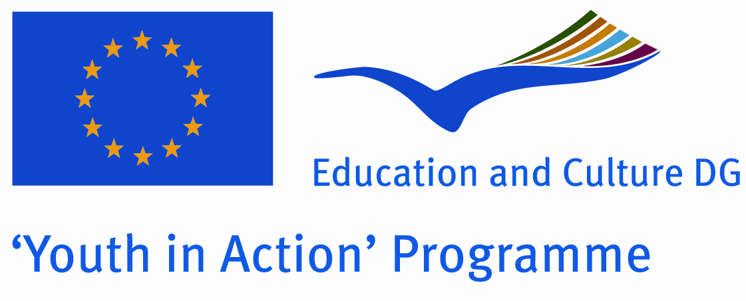 | Application for:  Action 1 - Youth for Europe  Sub-Action 1.1 - Youth Exchanges  Version valid as of 1 January 2010

Partner promoter
A. Details of the partner
Name
Street address
Postcode |  |  |  |  |  |  | City
Region |  |  |  |  |  |  | Country
Email |  |  |  |  |  |  | Website
Telephone |  |  |  |  |  |  | Telefax
Person in charge of the project (contact person)
Family name (Ms/Mr) |  |  |  |  |  |  | First name
Position/function
Email
Telephone |  |  |  |  |  |  | Telefax
B. Profile and role of the partner
Type and status | Non profit/non governmental organisation |  |  |  | Public body Informal group of young people
 | Body active at European level in the field of youth (ENGO) |  |  |  | Other – please specify:
Activity level | Local |  | Regional |  |  | National |  |  | European/International
 | Member organisation of the applicant
Role | Sending Organisation |  |  | Host Organisation
Please give a short description of your organisation/group (regular activities, member of, etc.):

C. Preliminary agreement of the partner
I, the undersigned, on behalf of O.S.T. – Organizaţia Studenţilor din Facultatea de Transporturi din cadrul Universităţii Politehnica Bucureşti
confirm our participation in each stage of the project: Europe Sweet Europe – Our Home
I declare having reached an agreement with all the promoters involved in the project with regard to the share of EU grant my organisation/group is entitled to receive in order to implement the project.
I confirm that my organisation/group has not applied for funding for this project to another National Agency or to the Executive Agency.
Furthermore, I confirm my undertaking to ensure visibility of the European Union support for the project and to ensure dissemination and exploitation of its results.
Name in capital letters:
Place: |  | Signature:
Date:

